**GEMS Institute of Higher Education**

**Department of Mathematics**

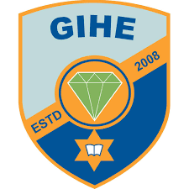

**Geometrical interpretation of scalar product of two vectors**

**A project work submitted in the partial fulfillment for the degree of High School in Mathematics**

Department of Mathematics

National Examination Board

GEMS Institute of Higher Education

Lalitpur, Nepal

2021

Submitted by: Submitted to:

Saimon Ghimire Ganesh Shiwakoti , Faculty of Mathematics

XI ‘D’ Dr. Jeevan Kafle , Faculty of Mathematics

Date Prakash Shrestha , HOD of Mathematics

**Declaration**

I am a student of GIHE Grade 11 ‘D’. I am glad to present this project entitled “Geometrical interpretation of scalar product of two vectors” in the partial fulfillment for the degree of High School in Mathematics for the academic year 2021. The following pages show the project in detail.

Any literature data or work done by others are cited within the reports and enlisted in reference. I assure you that this work has not been published elsewhere.

**Acknowledgement**

Due to the currently ongoing condition of our country caused by the uproar of COVID-19, we are unable to hand in a physical project, we are compelled to work with digital sources for this coursework. Even in times like these, we have the opportunity to indulge ourselves in projects like these. For this, I express my sincere gratitude and appreciation to GEMS School of Higher Studies.

I would like to acknowledge our college head Mr. Ganesh Datt Bhatta, Science Coordinator Mr. Govinda Raj Sharma, Department Head of Department of Mathematics Mr. Prakash Shrestha along with the faculties of chemistry Mr. Ganesh Shiwakoti and Dr. Jeevan Kafle.

Finally, am thankful to my parents for their unconditional love and support and my friends for helping me through every step of the project.